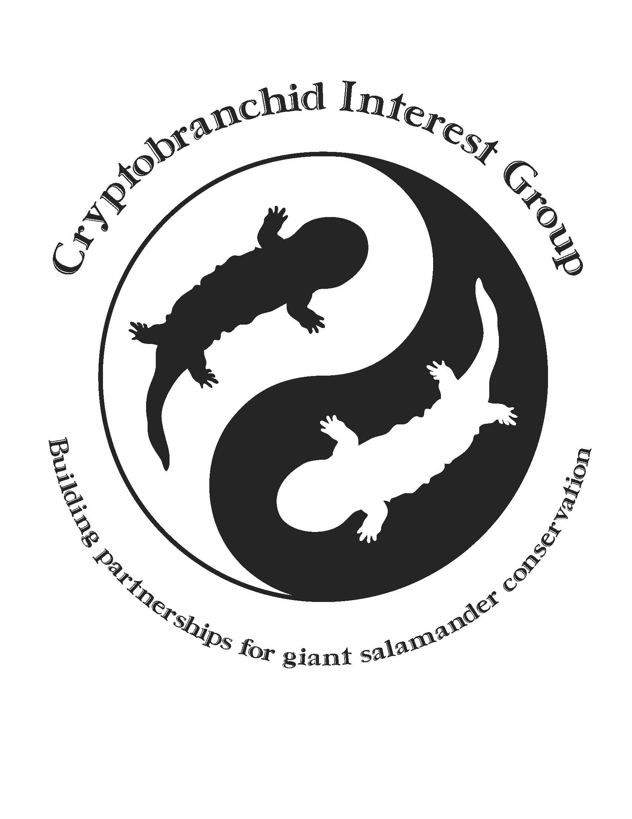

Cryptobranchid Interest Group

Conservation Grant

Application and Guidelines
The Cryptobranchid Interest Group (CIG) will consider proposals for two separate grants for amounts up to $2,000 each. Each applicant will automatically be considered for both grants when submitting this single application.

The Ron Goellner Conservation Fund awards up to $2,000 to projects related to all Cryptobranchids (Giant Chinese and Japanese salamanders, as well as hellbenders). Ron was a dedicated herpetologist and long-time advocate for the conservation of giant salamanders and served as the Director of Animal Collections at the Saint Louis Zoo.

The Jennifer Elwood Hellbender Conservation Grant awards up to $2,000 to projects related only to hellbenders. Dr. Elwood studied salamander morphology and ecology and was passionate about research and hellbender conservation.

FUNDING PRIORITIES:
These CIG grants were initiated to support projects that uphold the conservation priorities for giant aquatic salamanders. The CIG grant committee prefers projects that are broad in scope and over-all impact for the taxa in general and will select applications for funding based on the following:

- Broadness of application for conservation of giant salamanders.
- Field conservation of species and their habitats or mitigation of threats.
- Innovative education initiatives to benefit species at risk and their habitats.
- Research that has direct application to the health or recovery of species at risk.
- Partnerships and permits are approved and demonstrated.

The following are ineligible expenses/costs which are not supported:
- Salaries, except for graduate student stipends or technicians.
- Administrative costs, including institutional overhead. Travel unrelated to completion of the project. Grants may not be used for political lobbying, litigation, or travel funds for attending or presenting at conferences.
- General institutional support, projects considered to be normal institutional operating expenses, or shortfalls in budgets.
- Grants will not be provided to fund projects that are already completed.
- General field surveys or individual monitoring projects without broad applications to giant salamanders do not normally meet funding criteria

APPLICATION PROCEDURE AND DEADLINE
The proposal must be submitted via email as a single PDF file (including attachments) to the CIG grant coordinator (dbarber@fortworthzoo.org) by July 21st. Should the CIG grant committee recommend your project for funding, and it is approved in the budget process, we will disperse funds as specified in the award letter. Recipients will be notified by Aug 22nd of the same calendar year.

GRANT PERIOD
Grants must be spent within 12 months after the grant is awarded, and a final report, sent to the CIG grant coordinator, is required within 2 months of the completion of the project. Any project which extends beyond 12 months must submit a yearly report in addition to the final report due upon completion.

THE APPLICATION
Only complete applications will be considered for review and possible funding. Separate mailing of materials will not be accepted. The application contains 15 questions and a budget (see below), and must include the following in one pdf document:
- Support letters from collaborating institution or agency.
- Copies of permits or letters of approval by the appropriate regulatory agencies or recovery team, and/or Institutional Animal Care and Use Committee (IACUC) approvals.
- Curriculum vitae of Primary Investigator(s). Maximum one page per investigator.

Format must not deviate from the following form. Total application length (sections A, B and C) may not exceed seven typewritten pages. Appendices are permitted, but may only clarify, and not supplement, information in the narrative (i.e., photos/diagrams would be acceptable, but not videos/publications).

A) TITLE PAGE (Page 1; single page)
Project Title:
Principal Investigator (PI) name:
Job title:
Institution:
Address:
Phone:
Fax number:
Email address:
Name and contact information to whom check is payable or method of fund transfer:
Amount of Grant Request: | $
Collaborator name (add additional lines below if necessary):
Job title:
Institution:
Address:
Phone:
Fax number:
Email address:

Abstract (no more than 250 words):
B) NARRATIVE (Pages 2–5; no more than 4 pages in total).
8. Background (250 words maximum)
Please give a brief description of the project stating how it meets conservation or education goals and why it is a priority.

9. Expected Project Outcomes (250 words maximum).
Explain the specific conservation outcomes of the project, and how success will be measured. If the proposal request funds part of a larger project, the proposal must focus on the part for which funding is being requested.

10. Project Description (1000 words maximum).
Please provide a detailed account of the project methodologies and why they are appropriate, conservation significance of the specific outcomes, project evaluation, and partnerships involved (specify roles of all partners). If proposal is an education project, explain how the educational impact of the program be measured (i.e., changes in knowledge, attitudes, and behaviors)?

11. Describe the method and audience for sharing information gained from the project (100 words maximum).

12. If request involves a multi-year project, please outline the funding strategy for subsequent years (50 words maximum).

13. Have all the necessary permits or letters of approval by the appropriate regulatory agencies or recovery team been obtained for the project? (Y/N)
Have Institutional Animal Care and Use Committee (IACUC) approvals been obtained, if necessary? (Y/N)
If either are yes, attach copies of related permits and approvals to this proposal. Proposals cannot be considered unless proof of permits or support letters from the permitting authority is provided.

14. Project timeline:
Approximate Date | Method, product, or process

15. Is the project underway? (Y/N)

C) PROJECT BUDGET FOR ONE YEAR (add additional lines as necessary; not to exceed 1 page)
Budget Category | Item/Amount | Amount Requested from CIG | Other Funding Sources;  Identify Pending, In-Kind, or Other Support

D) ATTACHMENTS (Included in single pdf document for submission)
1. Letters of support from collaborating institution or agency.
2. Copies of appropriate permits and/or IACUC approvals.
3. Curriculum vitae of Primary Investigator(s). Maximum one page per investigator.

If funding is provided, the CIG requires that awardees recognize its support in all publications, copies of reports and publications are provided to the CIG, and that reports of progress be submitted as outlined in the grant application. The CIG also requests that 3–5 images be provided for informational purposes and for possible distribution to websites or publications.

Please sign below if you agree to these required conditions, and submit along with completed application

Signature of Applicant: __________________________________DATE:_________________________

